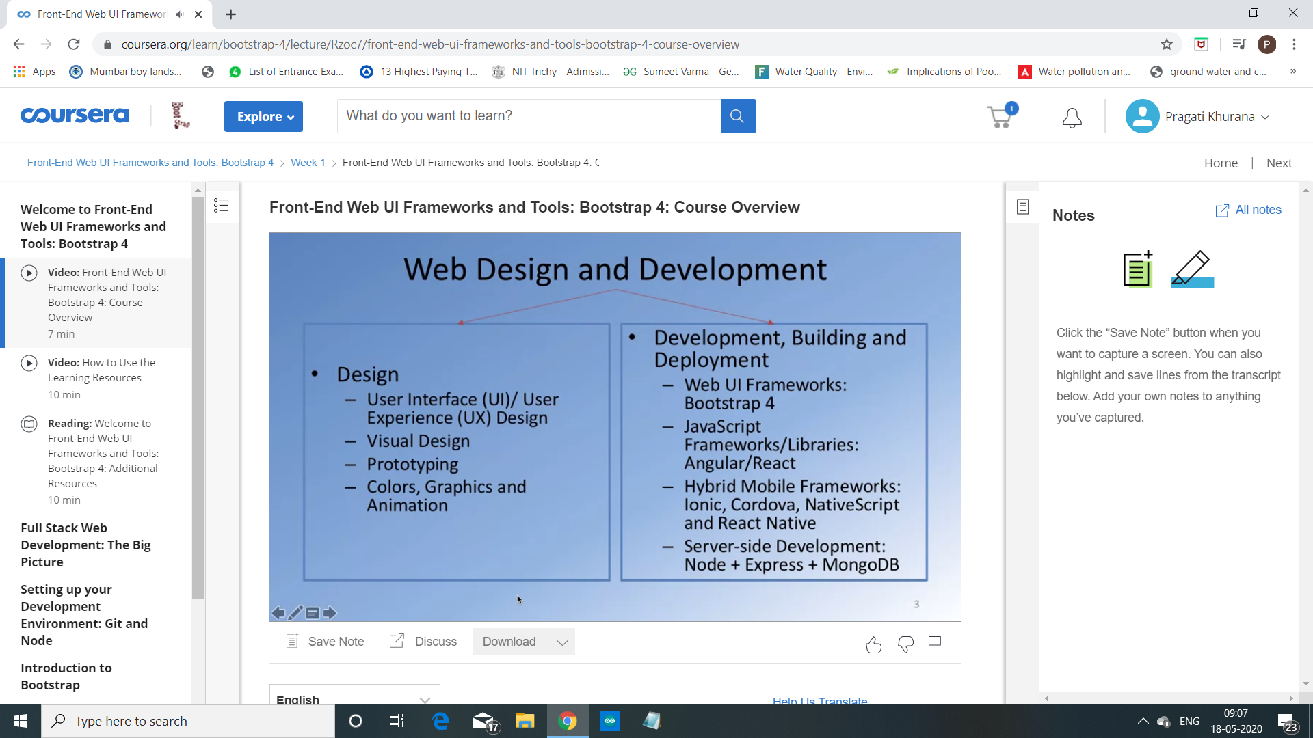

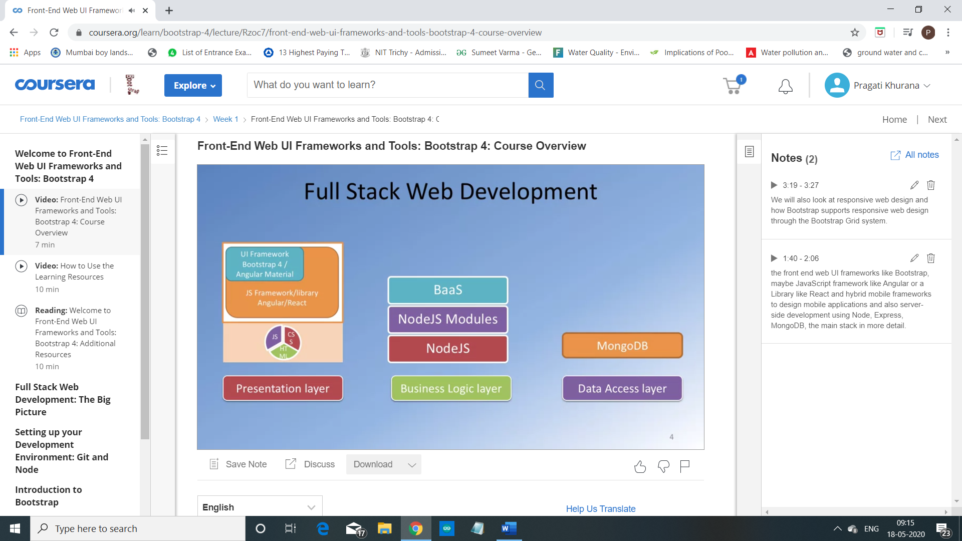

The front end web UI frameworks like Bootstrap, maybe JavaScript framework like Angular or a Library like React and hybrid mobile frameworks to design mobile applications and also server-side development using Node, Express, MongoDB, the main stack in more detail.

We will also look at responsive web design and how Bootstrap supports responsive web design through the Bootstrap Grid system.

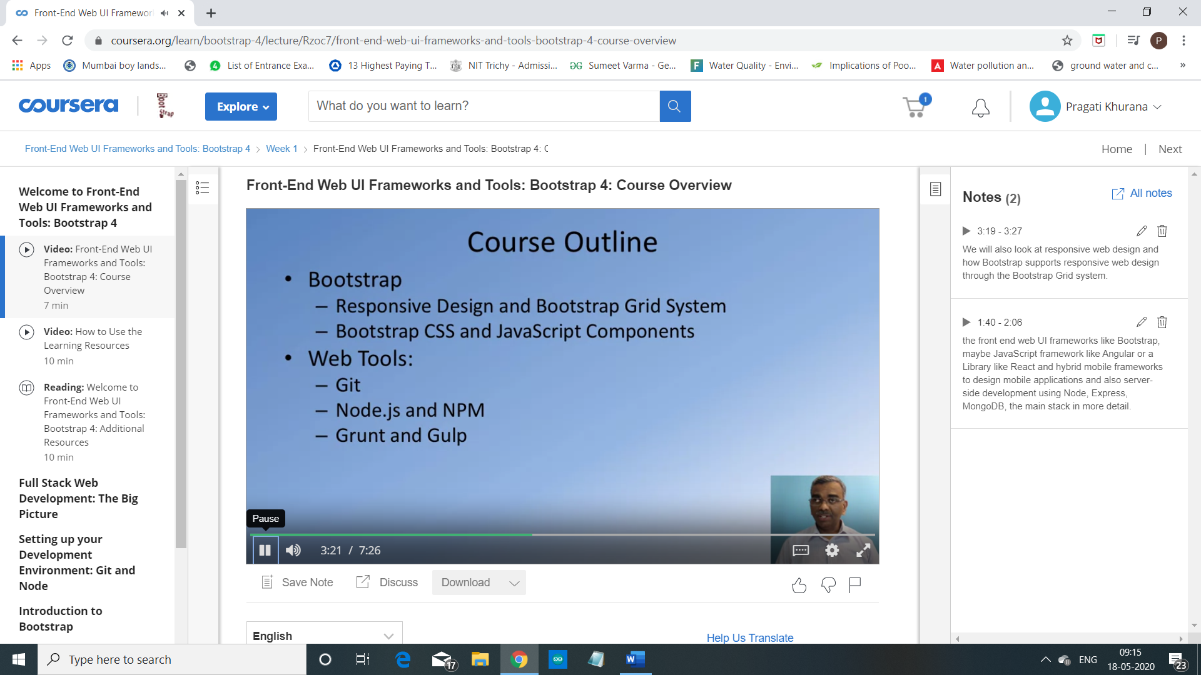

We'll briefly review Git, add Node.js and look at Noje.js based tools including task runners like Grunt and Gulp.

